1. Comparison of accuracies obtained using k-fold cross validation

for k = 5, 10 and, 20

|  |  |  |  |
| --- | --- | --- | --- |
| k | 5 | 10 | 20 |
| F1 score | 75% | 81% | 77% |

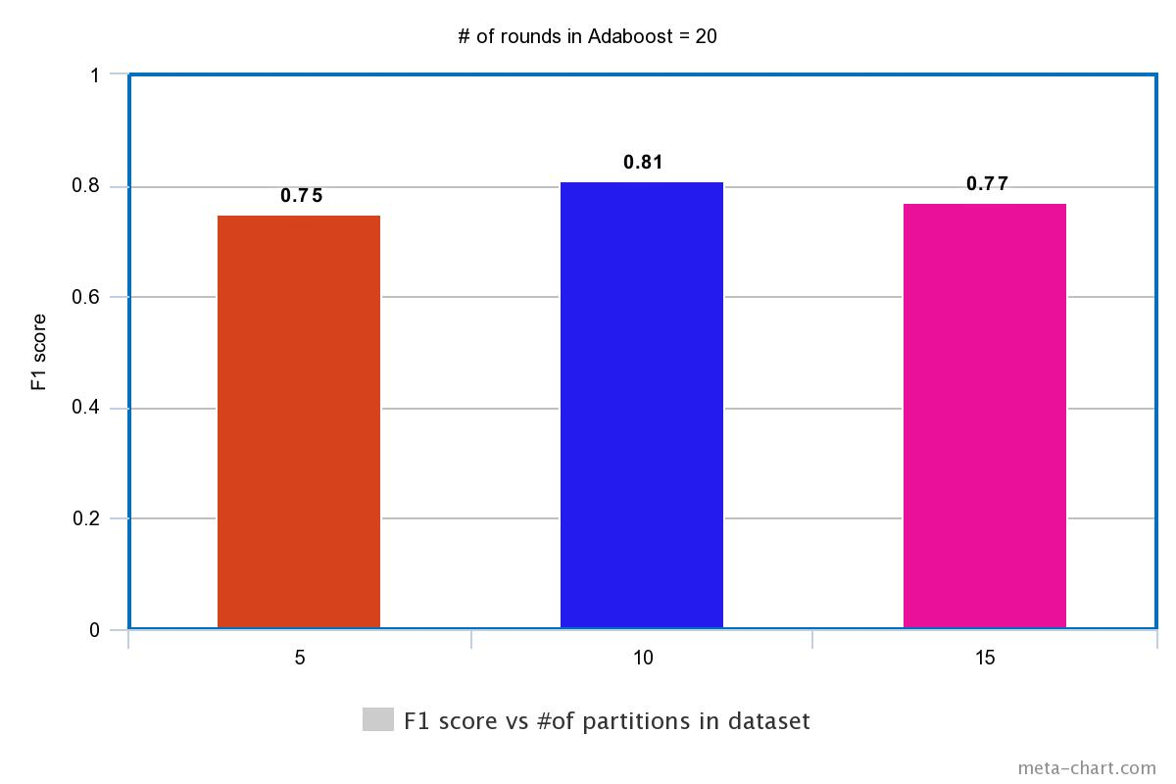

1. Comparison of the accuracies obtained by decision stump

and boosting with 30 rounds

|  |  |
| --- | --- |
| Decision Stump | 69% |
| Boosting with 30 rounds | 80% |

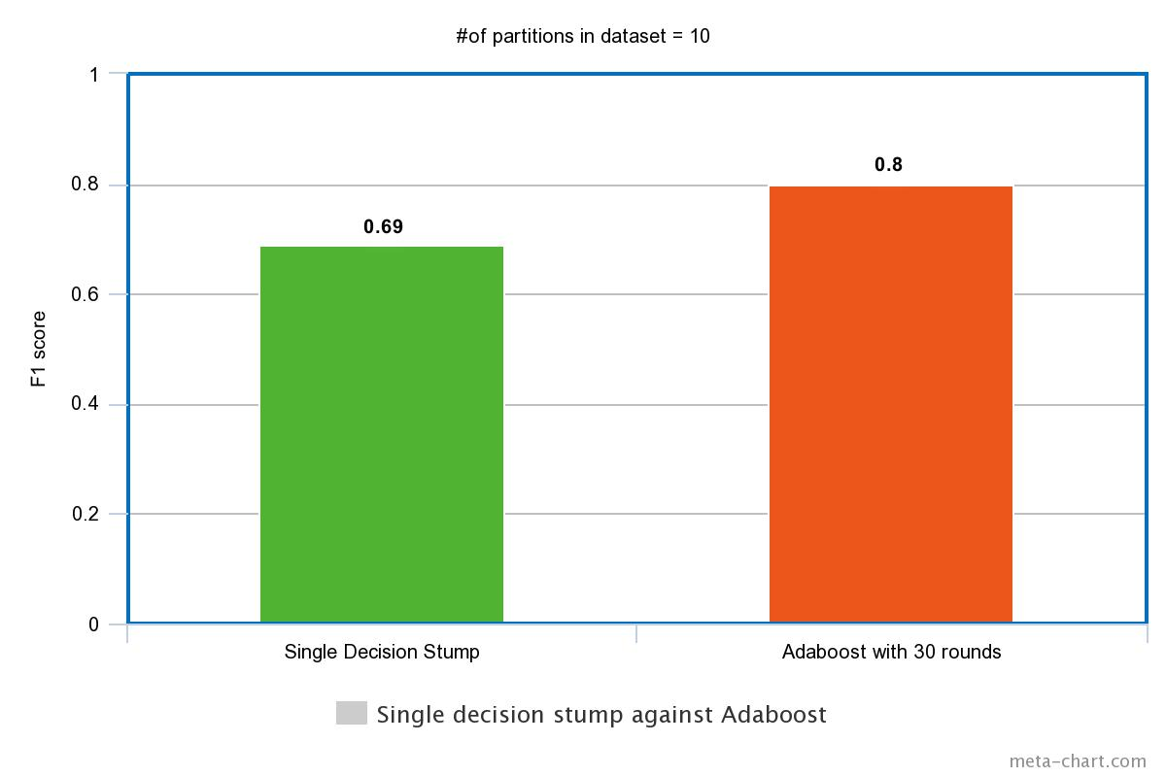

1. Comparison of the accuracies obtained by boosting with 5, 10 and, 20 rounds

|  |  |  |  |
| --- | --- | --- | --- |
| # of rounds | 5 | 10 | 20 |
| F1 score | 73% | 75% | 79% |

